Sticky Tape Activity

Part I – Top tapes

1. Take about a 15 cm piece of transparent tape and make a handle on the end by folding under the first cm of tape, sticky side to sticky side. Place this tape on the lab table. This is the base tape, label it “B1” for bottom.

2. Attach a second similarly prepared strip of tape on top of the base tape. Label this tape “T1” for top.

3. Repeat steps 1 and 2 so that you have two sets of base and top tapes.
T1
T2
B1
B2
Table
Table

4. Quickly peel the top tape (T1) off of the bottom tape (B1), and hang the T1 tape from the edge of the table. If the tape sticks to your hand, shake it off.

T1
Table

5. Quickly peel T2 from B2 and slowly bring T2 near T1.

_____ 5a. What do T1 and T2 do? Draw a picture and indicate the direction of the electrostatic forces.
- Hang straight down
- Repel one another
- Attract one another

_____ 5b. What can we conclude about the charges of T1 and T2? Draw a picture and indicate the direction of the electrostatic forces.
- They are the same
- They are opposite
- They have no charge

Part II – Top and Bottom Tapes

Discard all used tape from Part I before beginning Part II.

6. Make two setups as shown below, with a bottom (B), middle (M), and top (T) tapes.
T
M
B

7. Cut 2 pieces of paper, the same dimensions as the tapes, P1 and P2. Tape P1 so that it hangs over the edge of the table. Bring P2 near P1 without touching it. Draw a picture and indicate the direction of the electrostatic forces.

_____ 7a) What do P1 and P2 do?
- Hang straight
- Repel each other
- Attract each other

8. Cut 2 pieces of aluminum foil, A1 and A2. Tape A1 so that is hangs off the table, bring A2 near A1 without touching it. Draw a picture and indicate the direction of the electrostatic forces.

_____ 8a) What do A1 and A2 do?
- Hang straight
- Repel each other
- Attract each other

9. Slowly peel T1 and M1 off of B1 together as a pair. Then quickly separate them from each other. If they stick to your hand, shake them off.

10. Hang each strip next to the hanging paper and foil.
(don’t make any strip too close to its neighbors)

T1 A1 P1 M1 Table

11. Repeat step 9 with the other set of tapes.

12. Bring T2 near each hanging strip and write down what you see. Draw a picture and indicate the direction of the electrostatic forces for each question.

_____ 12a) When T2 is brought near T1, they
- hang straight
- repel
- attract

_____ 12b) When T2 is brought near A1, they
- hang straight
- repel
- attract

_____ 12c) When T2 is brought near P1, they
- hang straight
- repel
- attract

_____ 12d) When T2 is brought near M1, they
- hang straight
- repel
- attract

13. Bring M2 near each hanging strip and write down what you see. Draw a picture and indicate the direction of the electrostatic forces.

_____ 13a) When M2 is brought near T1, they
- hang straight
- repel
- attract

_____ 13b) When M2 is brought near A1, they
- hang straight
- repel
- attract

_____ 13c) When M2 is brought near P1, they
- hang straight
- repel
- attract

_____ 13d) When M2 is brought near M1, they
- hang straight
- repel
- attract

1. Imagine you could see the differences between the top and bottom tapes at the atomic level. On the partially separated T and B tapes discuss (4 – 6 sentences) how you could represent the way in which the tapes change as they are separated.

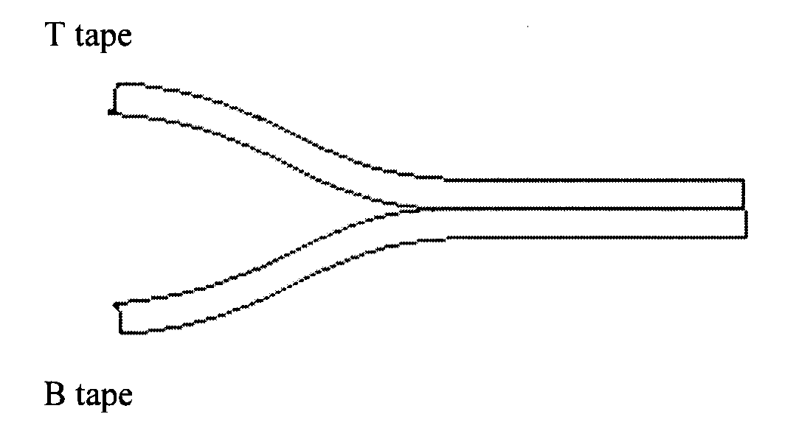

2. Explain (5 – 6 sentences) how the piece of paper could be attracted to both a top and a bottom tape while keeping these facts in mind. The paper is neutral and electrons can’t move away from the nucleus
+
Hint: Here is a normal atom with a positive nucleus and a negative electron cloud evenly spread around it.

Piece of paper
with five huge atoms
B tape
Piece of paper with five huge atoms
T tape

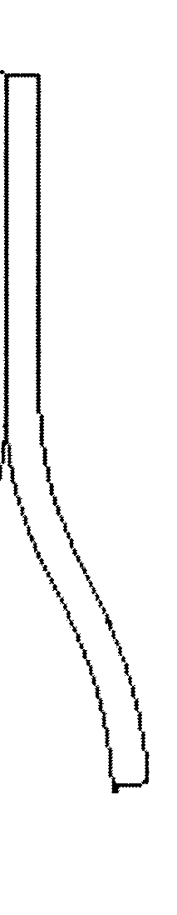

‘

3. Explain (5 – 6 sentences) how the piece of foil to be attracted to both a top and a bottom tape while keeping these facts in mind. The foil is neutral and each atom has a free electron that can move around
T tape
Piece of foil
B tape
Piece of foil

